**Chapter 10 Notes and Theorems**

**Arc length:**

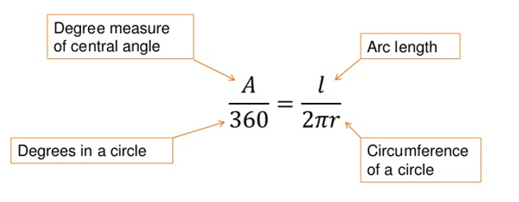

**Area of Sector:**

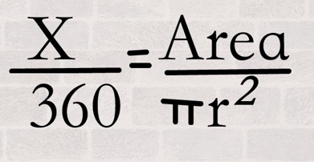

**THEOREM (1): A line tangent to a circle is perpendicular to the radius at the point of tangency**

**Converse, too!**

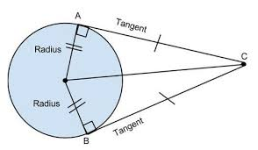

**THEOREM (2): If two segments are tangent to a circle, then they are congruent.**

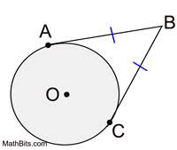

**THEOREM (3) – if two chords are congruent, then the central angles that formed them are also congruent.**

**CONVERSE**

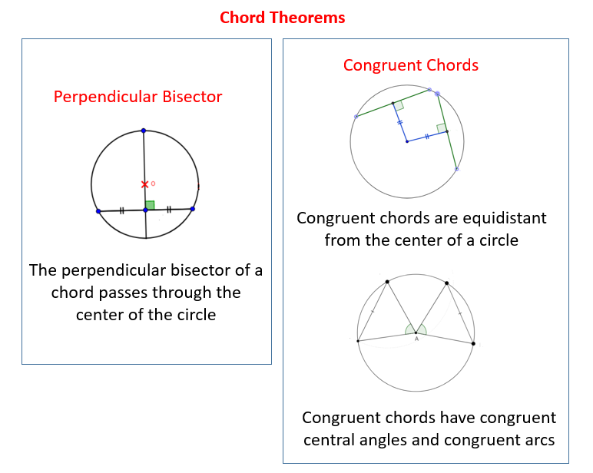

**THEOREM (4) – If two arcs are congruent, then their chords are congruent.**

**CONVERSE**

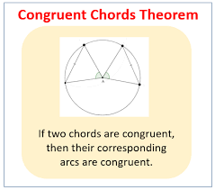

**BONUS THEOREM-DEFINITION**

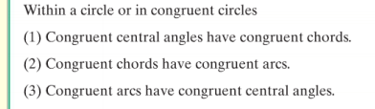

**THEOREM (5)**: **If chords are equidistant from the center, they are congruent.**

**CONVERSE**

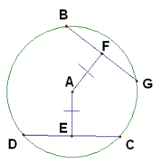

**THEOREM (6) If a diameter is perpendicular to a chord, then it bisects the chord (and its arc).**

**CONVERSE**

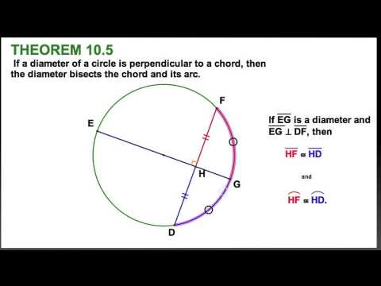

**THEOREM (7) The perpendicular bisector of a chord contains the center of the circle (passes through the center)**

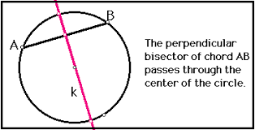

**THEOREM (8) The measure of an inscribed angle is HALF the measure of its intercepted arc.**

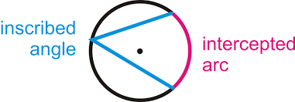

**COROLLARIES**

* **Inscribed angles that intercept the same arc are congruent.**
* **An inscribed angle that cuts off a semicircle is a right angle**
* **Opposite angles of a quadrilateral INSCRIBED in a circle are always supplementary**

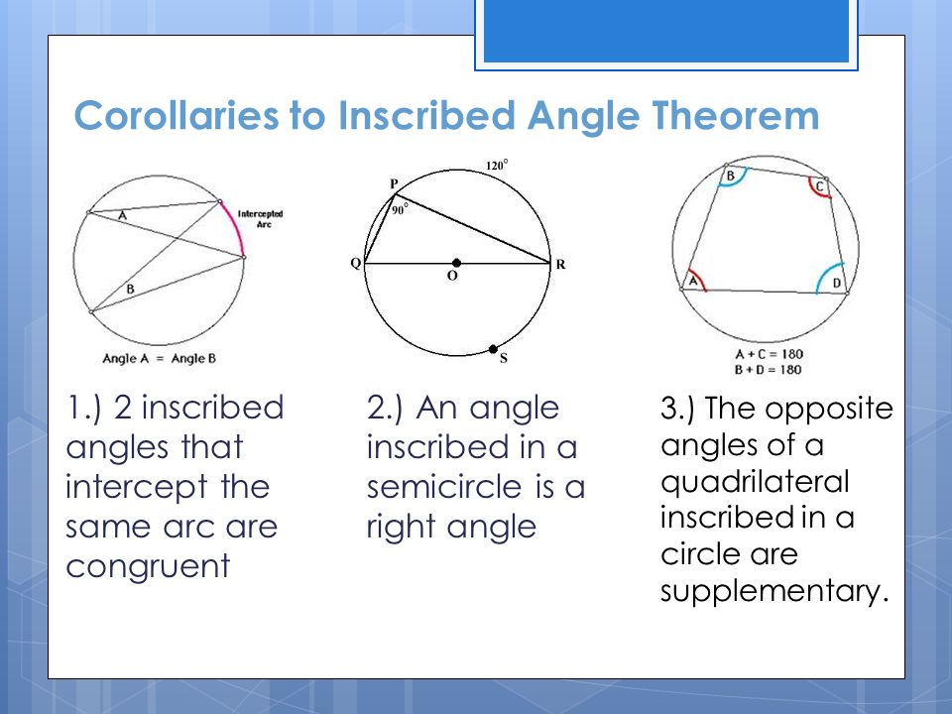

**Theorem (9) – The measure of an angle formed by a tangent and a chord is half the measure of it intercepted arc.**

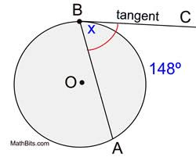

**Theorem (10) – The measure of an angle formed by secant lines that intersect inside a circle is half the sum (the average) of the two intercepted arcs.**

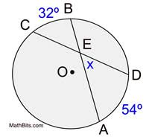

**Theorem (11) – The measure of an angle formed by two lines that intersect outside a circle is half the DIFFERENCE of the two intercepted arcs.**

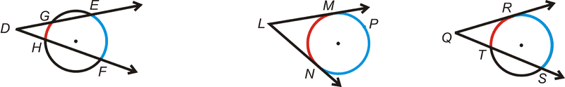

**Case 1 Case 3 Case 2**

**Theorem (12) – The product of the lengths of two segments from the point of intersection to the circle is constant along any line that passes through the point and the circle.**

