**Theorem (9) – The measure of an angle formed by a tangent and a chord is half the measure of it intercepted arc.**

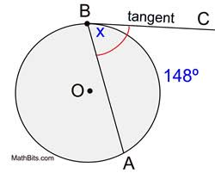

**Theorem (10) – The measure of an angle formed by secant lines that intersect inside a circle is half the sum (the average) of the two intercepted arcs.**

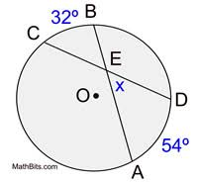

**Theorem (11) – The measure of an angle formed by two lines that intersect outside a circle is half the DIFFERENCE of the two intercepted arcs.**

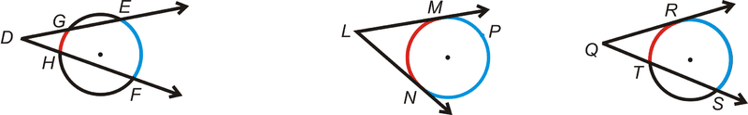

**Case 1 Case 3 Case 2**

**Theorem (12) – The product of the lengths of two segments from the point of intersection to the circle is constant along any line that passes through the point and the circle.**

